Analysis

Analysis :

Project is a supervised categorical problem. Any of the native classification algorithm can be used to classify the employee performance. Tried various approached like logistic regression, svc but applied Random forest classifier algorithm which gave nearly 90% accuracy with Grid search CV technique.

Few highlights for pre-processing of the data

- For categorical data, used the get dummies method than label encoder.
- For field like EducationBackground,EmpDepartment,MaritalStatus,BusinessTravelFrequency,OverTime and Attrition assigned the category manually.
- For EmpJobRole, used label encoder for converting it to numerical.
- The datasest as such was balanced hence no data balancing techniques are used.

Data Analysis :

Employees having respective rating

Performace Rating | Employee Count
3 | 874
2 | 194
4 | 132

Employee count with respect to every department

Department | Employee Count
Life Sciences | 492
Medical | 384
Marketing | 137
Technical Degree | 100
Other | 66
Human Resources | 21

Employee count with respect to job role

Sales Executive 270
Developer 236
Manager R&D 94
Research Scientist 77
Sales Representative 69
Laboratory Technician 64
Senior Developer 52
Manager 51
Finance Manager 49
Human Resources 45
Technical Lead 38
Manufacturing Director 33
Healthcare Representative 33
Data Scientist 20
Research Director 19
Business Analyst 16
Senior Manager R&D 15
Delivery Manager 12
Technical Architect 7

Usage of Principal Component Analysis
Used PCA to look at the perspective of the dimensional reduction. Its observed that, first 15 predictors add up to the 9920895929366909% data. But gave performance of 84.4 with randome forest.

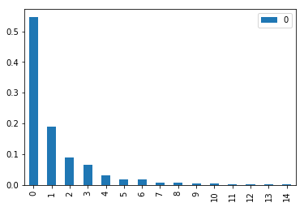

Features that are influencing the performace
Used Randome forest regressor to find out the features which are impacting the performace of the employee for the given set of data.
https://blog.datadive.net/selecting-good-features-part-iii-random-forests/

Feature Distribution :

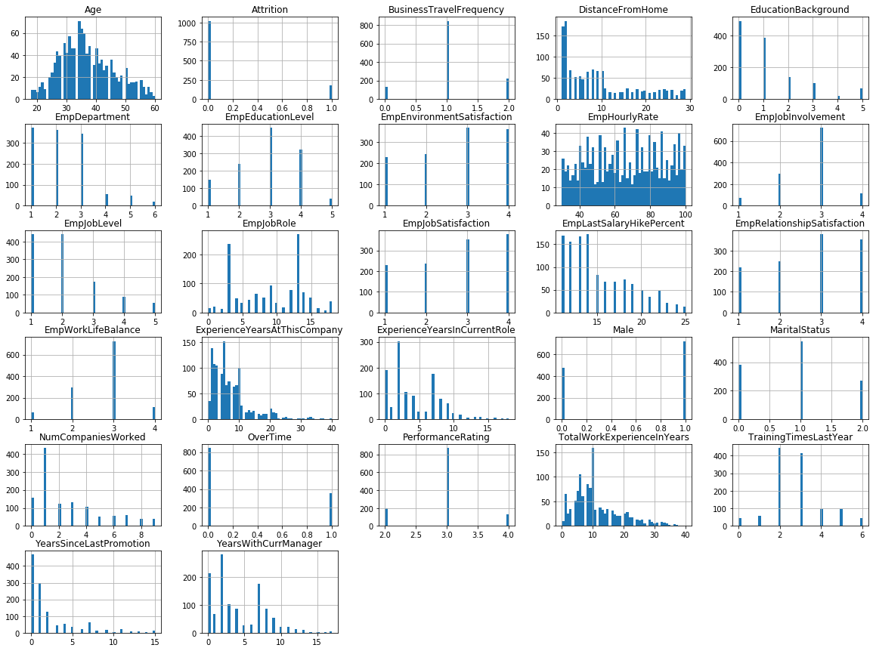

Department wise relationship with target
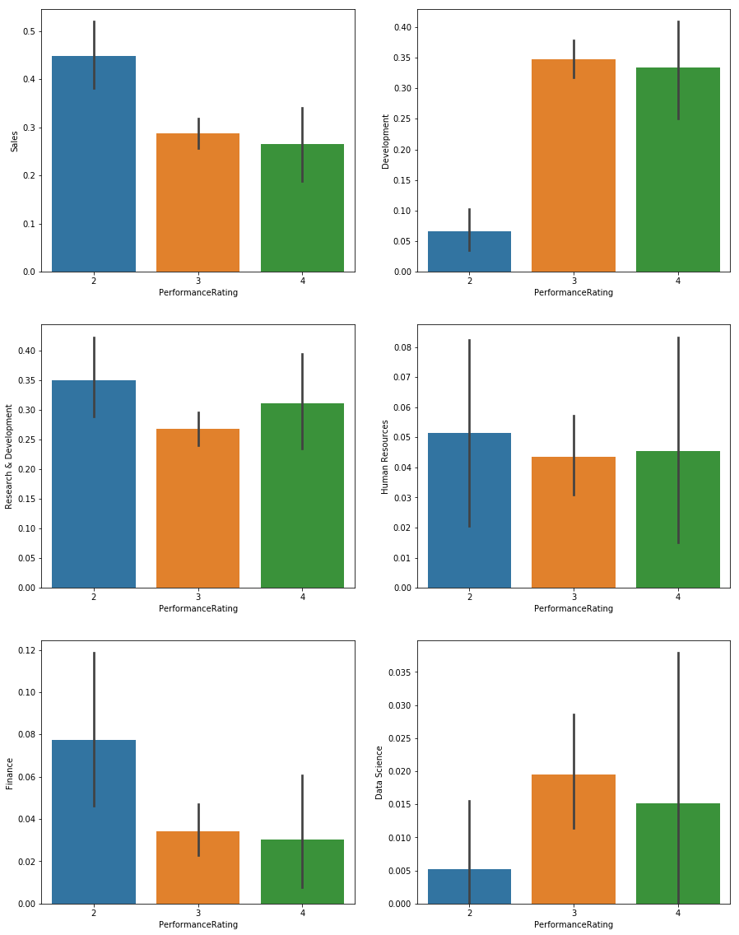

Predictor relationship with target
